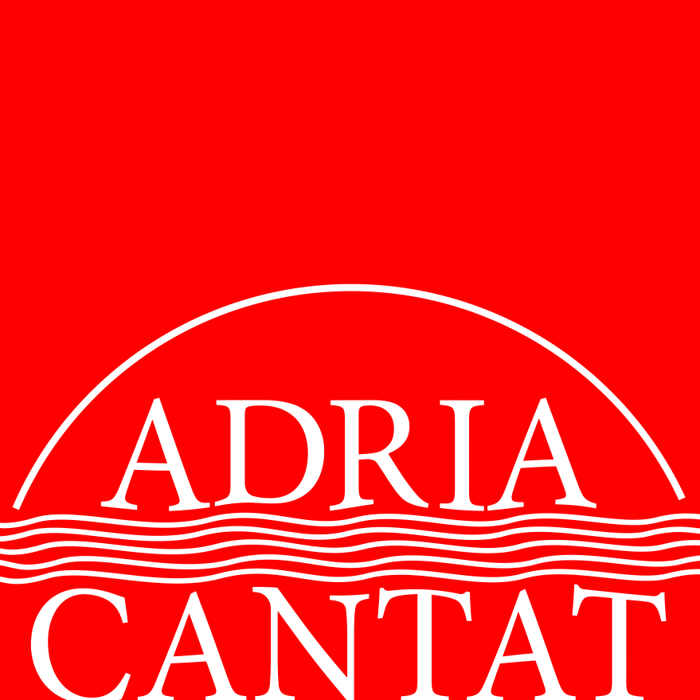

2014.

APPLICATION FORM

Choir Name
Number of singers
Choir website
Town/postal code
Street address
Contact person
Telephone
E-mail
Conductor
Telephone
E-mail

 | Composer/arranger  (full name) | Composition/Arrangement | Type of performance/  Instrumental backing  (a cappella/accompanied by) | Duration
1
2
3
4
You can register 3 - 4 compositions/arrangements, together lasting from 9 to 12 minutes.

Category

Category A – National Folkloristic Music

A1 - Small Mixed Choir
A2 - Small Male Choir
A3 - Small Female Choir
A4 - Small Children Choir
A5 - Big Mixed Choir
A6 - Big Male Choir
A7 - Big Female Choir
A8 - Big Children Choir

Category B – Foreign Folkloristic Music

B1 - Small Mixed Choir
B2 - Small Male Choir
B3 - Small Female Choir
B4 - Small Children Choir
B5 - Big Mixed Choir
B6 - Big Male Choir
B7 - Big Female Choir
B8 - Big Children Choir

Every choir may compete in two categories. For every category a choir wishes to compete in, an additional filled application form is necessary.

To register, you must send the following:

Via e-mail:
- filled application form as a word document or PDF file
- choir photograph in high resolution
- conductor photograph in high resolution
- choir CV, short (Word-100 words at most)
- conductor CV, short (Word-100 words at most)

Via mail:
- four copies of the scores for the registered compositions/arrangements

The registration fee amounts to:
- 150 Euros for competing in a single category
- 200 Euros for competing in two categories

Make payment to the account:
Hrvatska udruga zborovođa - SWIFT: ZABA HR2X - IBAN: HR6023600001102023177
Bank name/adress: ZAGREBAČKA BANKA, Trg bana Josipa Jelačića 10, 10000 Zagreb, Croatia

The organizer will inform the choir on whether their participation was accepted or not. The choir must, within seven days of receiving the notice, pay the application fee and send the receipt to HUZ Croatian Choral Directors Association. Please make sure all the information is correct and that all names are complete. The registration deadline is May 1st, 2014.

HUZ Croatian Choral Directors Association
Vrbik 11
HR-10000 Zagreb
Croatia

info@choralcroatia.com

All other information is available via phone: +385-98-275961 and +385-1-6198469.

www.choralcroatia.com

